**PYSPARK**

**CASE STUDY**

**UBER ANALYSIS**

**PALLAV GUPTA**

**46022374**

**CONNECTING JUPYTER TO SPARK**



## IMPORT NECESSARY LIBRARIES

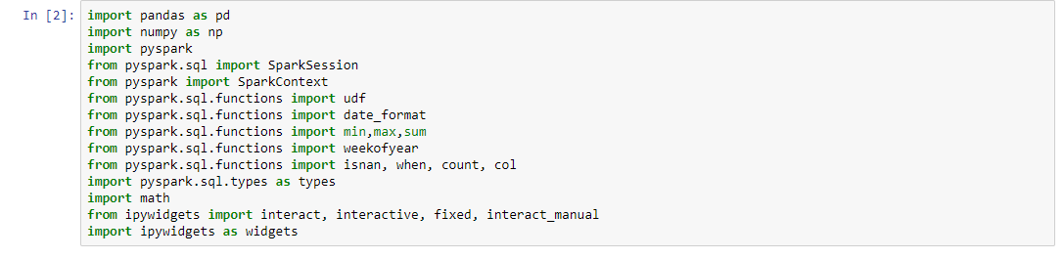

**IMPORTING DATA**



**APPENDING DATA**

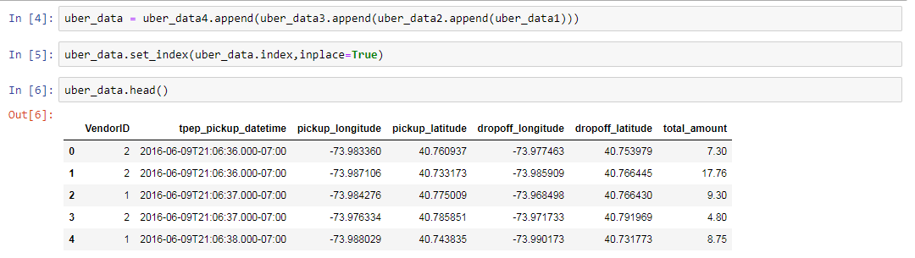

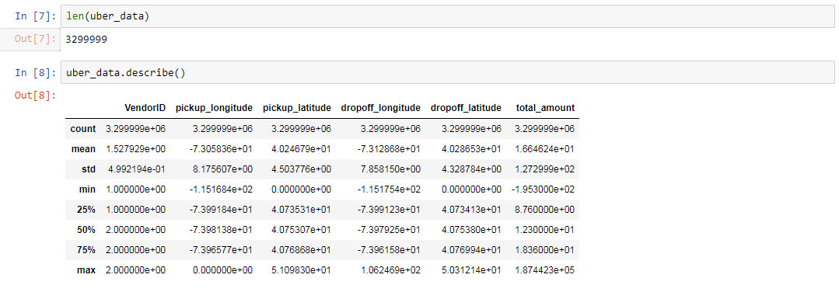

**CREATE INDEX**

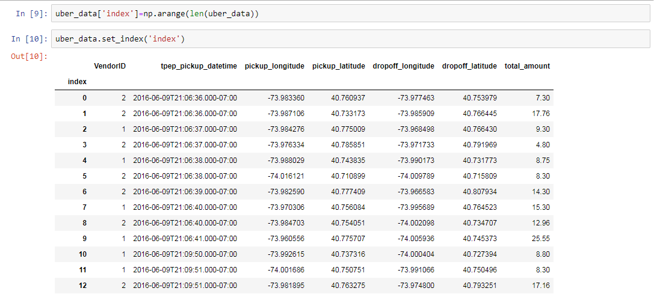

**IMPORT DATA INO SPARK**

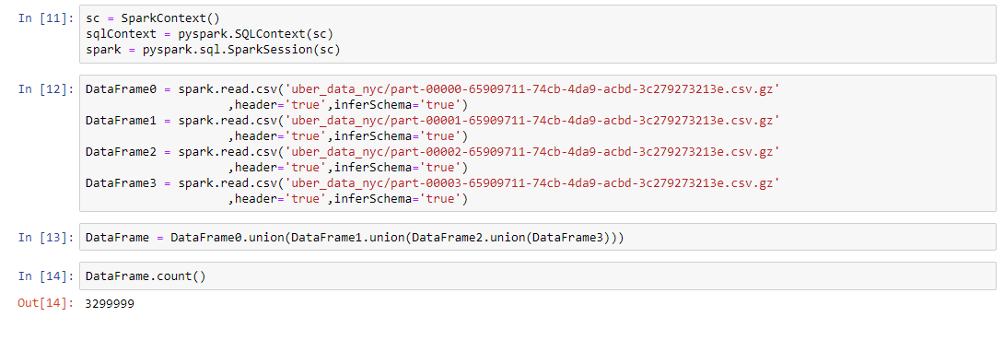

1. **USE THE HAVERSINE FORMULA TO CALCULATE THE DISTANCE FROM THE LATITUDES OF THE PICKUP AND DROP POINTS. INCLUDE THE FORMULA IN A PYTHON PACKAGE AND CREATE THE NECESSARY USER DEFINED FUNCTIONS IN SPARK. STORE THE DATA AS A CSV FILE.**

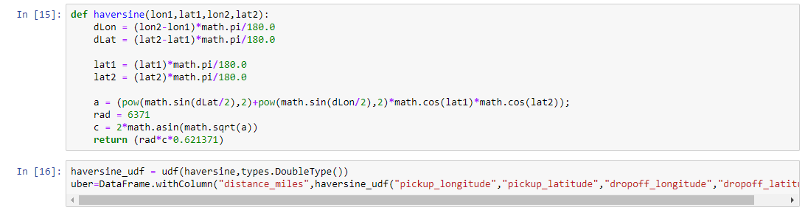

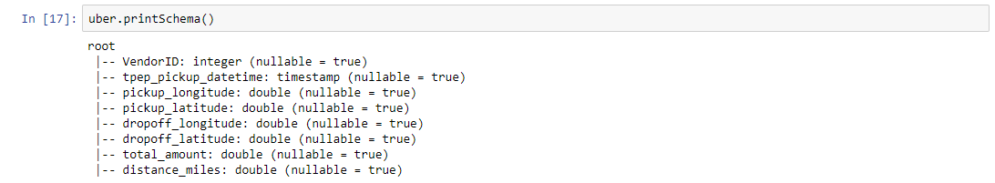

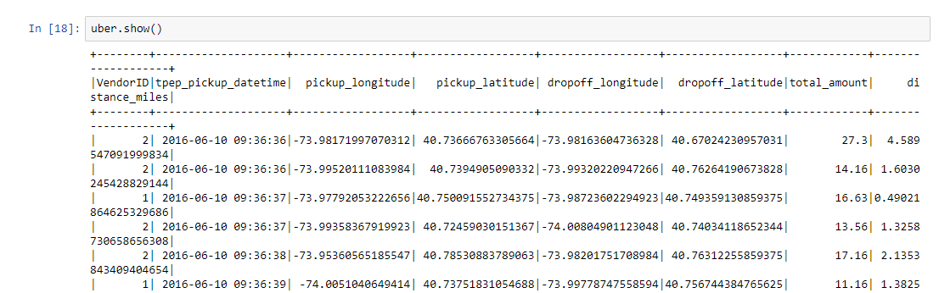



**CLEANING DATA BEFORE STORING**

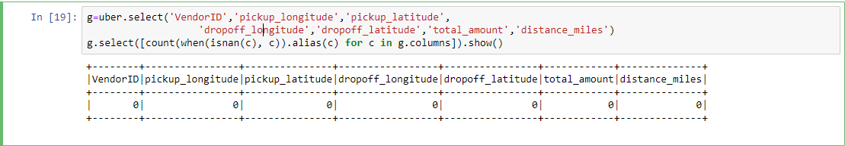

## FIND THE DATE RANGE FROM THE NEWLY CREATED CSV FILE

**USING SQL QUERY:**

spark.sql('select min(tpep_pickup_datetime) as dateRange from uber union select max(tpep_pickup_datetime) from uber').show()

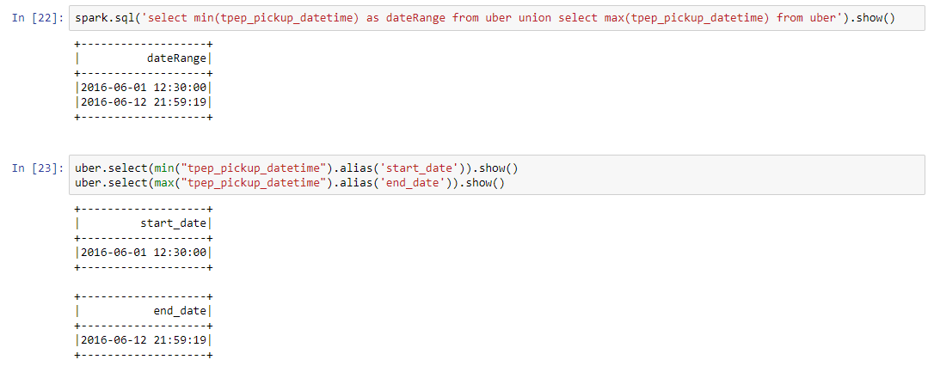

**USING DATAFRAME SQL FUNCTIONS:**

uber.select(min("tpep_pickup_datetime").alias('start_date')).show()

uber.select(max("tpep_pickup_datetime").alias('end_date')).show()



## AGGREGATE DATA BASED ON WEEK TO DEPICT WEEKLY DISTANCE OF TRAVEL

**USING SQL QUERY:**

spark.sql("select weekofyear(tpep_pickup_datetime) as week,sum(distance_miles) as total_distance from uber group by weekofyear(tpep_pickup_datetime)").show()

## 

**USING DATAFRAME SQL FUNCTIONS:**

uber.groupBy(weekofyear("tpep_pickup_datetime").alias("date_by_week")).agg(sum("distance_miles")).orderBy("date_by_week").show()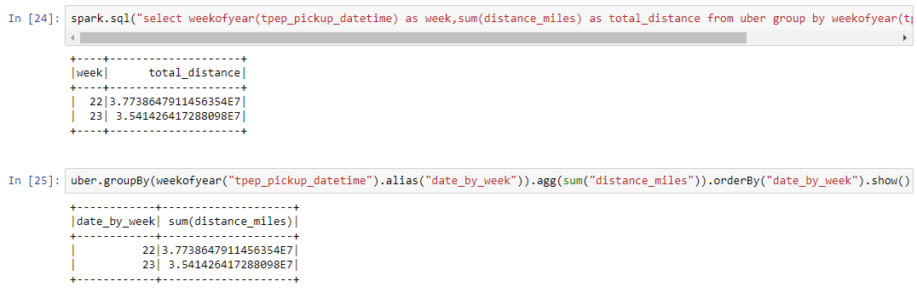

1. **IDENTIFY THE VENDOR COVERING THE HIGHEST MILES.**

**USING SQL QUERY:**

spark.sql('select VendorID from uber group by vendorID order by sum(distance_miles) desc limit 1').show()

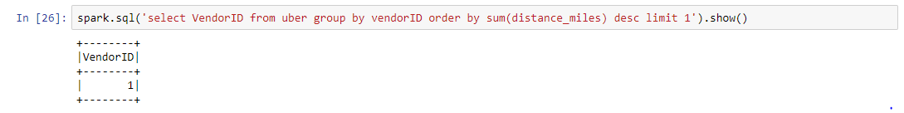

**USING DATAFRAME SQL FUNTCIONS:**

(uber.select("VendorID","distance_miles").groupBy('VendorID').agg(sum('distance_miles').alias('Sum_distance'))).select("VendorID").orderBy("Sum_distance",ascending=False).show(1)

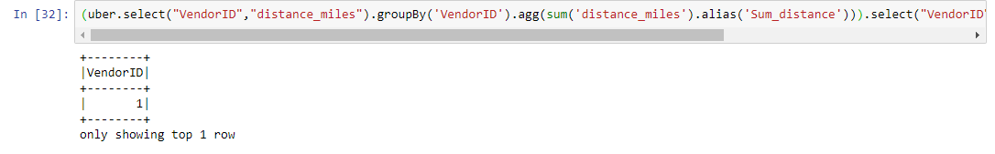

1. **CALCULATE THE TOTAL REVENUE MADE OVER A PERIOD OF CHOICE**

**CREATING A SLIDER:**

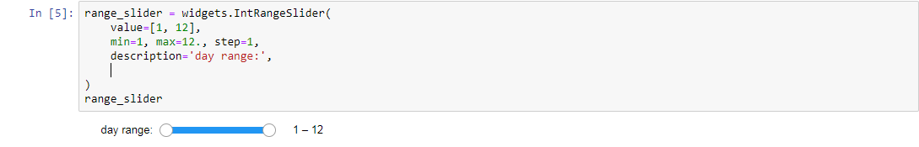

**USING SQL QUERY:**

query=("select sum(total_amount) as total_revenue from uber where dayofmonth(tpep_pickup_datetime) between {} and {}"

.format(range_slider.value[0],range_slider.value[1]))

spark.sql(query).show()

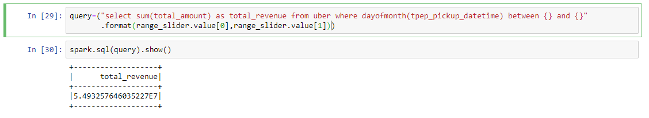

**USING DATAFRAME SQL FUNCTIONS:**

(uber.filter((uber["tpep_pickup_datetime"]>="2016-06-10 04:06:40") & (uber["tpep_pickup_datetime"]<="2016-06-12 16:29:14"))).agg(sum('total_amount').alias('total revenue between 2016-06-10 04:06:40 & 2016-06-12 16:29:14')).show()

